Universidad de Guadalajara
Centro Universitario de los Valles



Configuration identification report

Subject: Administración de la configuración del software
Teacher: Zatarain Duran Omar Ali
Version: 3
Autor: Nava Cervantes José Manuel

Content table

Introduction 3
CR01.- Create a module that sends the attendance to an external surveillance system that fulfills a mandatory government law. 4
Identify the configuration items (CI) within the baseline due to change request (CR) 4
Changes in SDD (Software Design Document) 4
General architecture 4
Class diagram 5
Deployment diagram 6
Activity diagram 8
Changes in SRS (Specification Requirement Software) 9
Figure out the effort required to implement such CR (budget, work, human resources, time). 9
Enact (analysis) the advantages and disadvantages for implementing the CR. 11
CR02.- A cryptographic method should be used to transform transmission data for privacy purposes. 12
Identify the configuration items (CI) within the baseline due to change request (CR) 12
Changes in SDD (Software Design Document) 12
Class diagram 12
Changes in SRS (Specification Requirement Software) 13
Figure out the effort required to implement such CR (budget, work, human resources, time). 13
Enact (analysis) the advantages and disadvantages for implementing the CR. 13
CR03.- The client asks for a resilient version of Viola-Jones algorithm to detect the face of a handicapped person who only has one eye. 14
Identify the configuration items (CI) within the baseline due to change request (CR) 14
Changes in SDD (Software Design Document) 14
General architecture 14
Changes in SRS (Specification Requirement Software) 15
Figure out the effort required to implement such CR (budget, work, human resources, time). 15
Enact (analysis) the advantages and disadvantages for implementing the CR. 15

Introduction

The stakeholders want to change and implement 3 different changes in the project named “Sistema para la gestion del acceso y uso de aulas, via reconocimiento facial, basado en Raspberry Pi”. We must assign different ID for each change requirement in the project. These changes are the following:

CR01.- Create a module that sends the attendance to an external surveillance system that fulfills a mandatory government law.
CR02.- A cryptographic method should be used to transform transmission data for privacy purposes.
CR03.- The client asks for a resilient version of Viola-Jones algorithm to detect the face of a handicapped person who only has one eye.

According to steps for configuration indication, it is necessary identify 3 different points:

- Identify the configuration items (CI) within the baseline due to change request (CR).
- Figure out the effort required to implement such CR (budget, work, human resources, time).
- Enact (analysis) the advantages and disadvantages for implementing the CR.

CR01.- Create a module that sends the attendance to an external surveillance system that fulfills a mandatory government law.

Identify the configuration items (CI) within the baseline due to change request (CR)

Changes in SDD (Software Design Document)

General architecture

It will be necessary to add another module; we will be named “Module attendance”. It is explained in the figure 1, with the general architecture and the new module.

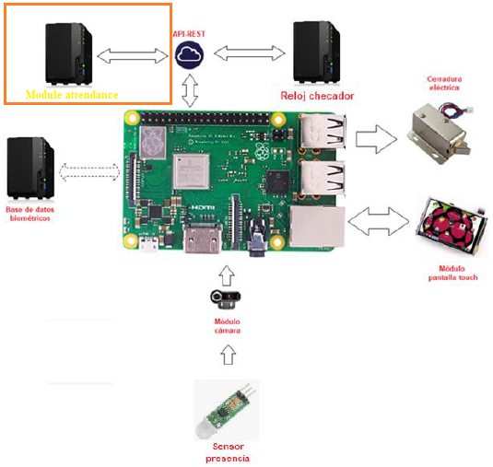

Figure 1.- General architecture with the new “Module attendace”.

Figure 1.- General architecture with the new “Module attendace”.

Class diagram

In this part, only it will be necessary to add another method, which we will named “conexiónModuleAttendance”. This method communicates the system with the “ModuleAttenddance” through APIREST class.

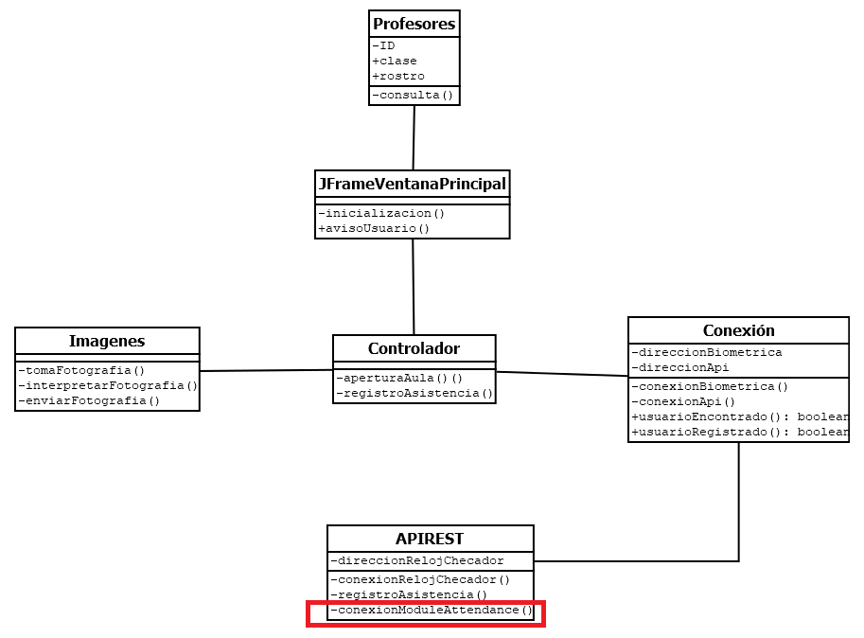

Figure 2.- Class diagram with the new “Module attendace”.

Deployment diagram

In this diagram, only we will add another module, like a physical component external through APIREST.

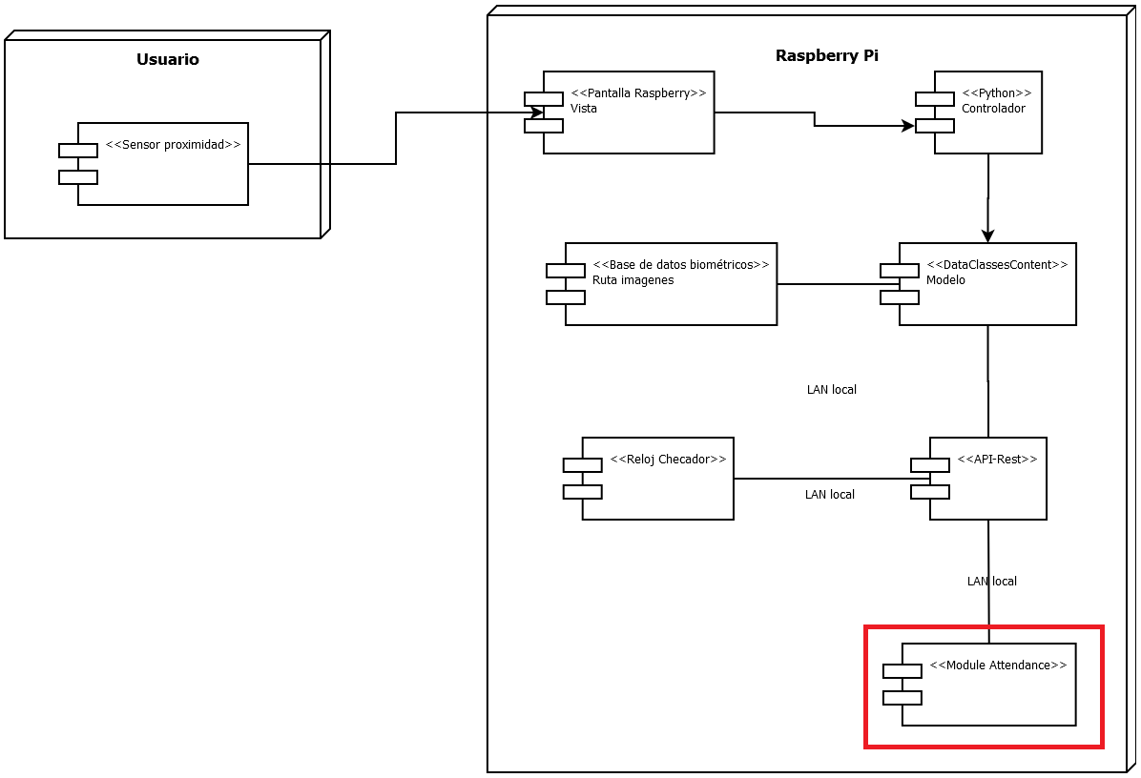
Figure 3.- Deployment diagram with the new “Module attendace”.

Activity diagram

The changes in this diagram will be to add a branch, in the module APIREST, named “conexión APIREST”, it is explained in the figure 4.

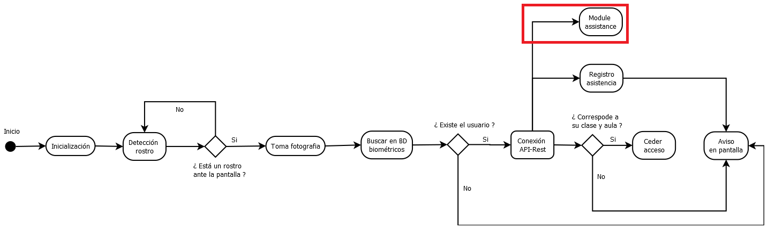
Figure 4.- Activity diagram with the new “Module attendace”.

Changes in SRS (Specification Requirement Software)

In this document is only necessary to add another functional requirement. To practical situations we will named SRF-08

SRF-08 | The system should send the assistance, after the SRF-05(Registro de asistencia), to the module named “module attendance”.
External attendace

Figure out the effort required to implement such CR (budget, work, human resources, time).

The requirements to implement this project from the beginning were the next:

Budget
- $800,000.00 MXN approximately.

Work
- 1,000 line of code to Module attendance(through API REST).

Human resources
- One junior programmer.
- 2 internal senior programmers (stakeholders).
- 5 software engineering.

Time

- 2 years (January 2020 – December 2021) to develop and implement.
As in the new module, it will only be to add another extra functionality, such as the connection through the API-REST. The required effort will be as follows (It is estimated that the changes, could affect in this topic):

Budget
- $24,000.00 MXN more.

Work
- 2 months more to develop and implement the new module “Module attendance”.

Human resources
- Only a more programmer junior.

Infrastructure
- 20 MB of internet (minimum to operate).

Enact (analysis) the advantages and disadvantages for implementing the CR.

It is necessary, differentiate advantages and disadvantages of these changes, in case of we accept. The next table describe these points (table 1):

Create a module that sends the attendance to an external surveillance system that fulfills a mandatory government law.

Advantages | Disadvantages
The system fulfills the law. | More expensive.
The system fulfills the law. | More time to design and develop.
The system fulfills the law. | More hardware and electrical cost.
The system fulfills the law. | More external modules.
Table 1.-Advantages and disadvantages to first change.

Consider the risk in all topics, cost, time, client, situation, etc.

CR02.- A cryptographic method should be used to transform transmission data for privacy purposes.

Identify the configuration items (CI) within the baseline due to change request (CR)

Changes in SDD (Software Design Document)

Class diagram

In this case only it will be necessary to add another method in the class “Conexion”, to encrypt data before of transfer through APIREST. This method will be named “encriptar”.

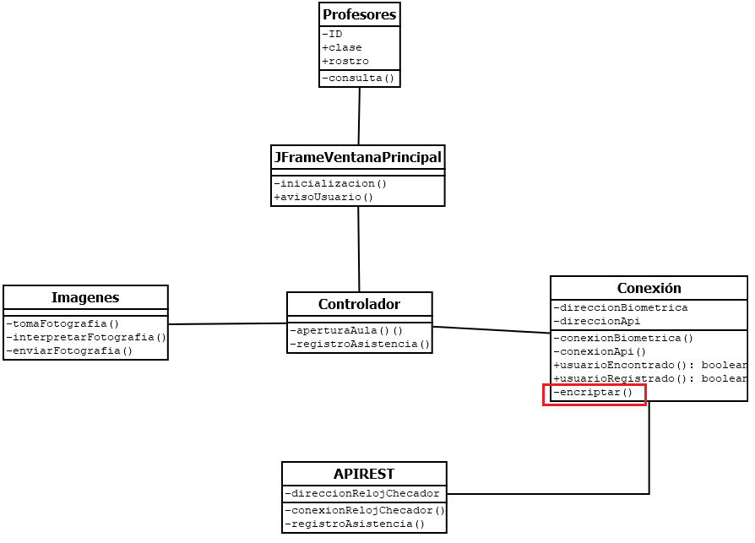
Figure 5.- Class diagram with the new method.

Changes in SRS (Specification Requirement Software)

In this document is only necessary to add another functional requirement. To practical situations we will named SRF-09

SRF-09 | The system should have a cryptography method before to storage in the database.
Encryptation data

Figure out the effort required to implement such CR (budget, work, human resources, time).

As in the new module, it will only be to add another extra method, such as encrypt data. The required effort will be as follows (It is estimated that the changes, could affect in this topic):

Budget
- $1,000.00 MXN more.

Work
- 2 days more to develop and implement the new method “Encryptation data”.

Human resources
- 1 programmer

Enact (analysis) the advantages and disadvantages for implementing the CR.

A cryptographic method should be used to transform transmission data for privacy purposes.

Advantages | Disadvantages
Stronger system | More expensive.
Stronger system | More time to design and develop.
Most reliable system. | More complex software.
Most reliable system. | More hardware and electrical cost.
Table 2.-Advantages and disadvantages to second change.

CR03.- The client asks for a resilient version of Viola-Jones algorithm to detect the face of a handicapped person who only has one eye.

Identify the configuration items (CI) within the baseline due to change request (CR)

Changes in SDD (Software Design Document)

General architecture

For this change requirement is necessary to use another board (instead of Raspberry Pi), because is more computational processing power to implement this algorithm.

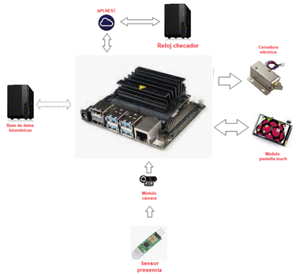

Figure 6.- General architecture with the new board NVIDIA Jetson Xavier NX.

Changes in SRS (Specification Requirement Software)

In this document is only necessary to add another functional requirement. To practical situations we will named SRF-10

SRF-10 | The system must be able to operate with facial features other than the eyes, even relying on other algorithms.
Inclusive algorithm.

Figure out the effort required to implement such CR (budget, work, human resources, time).

For this change is necessary to implement a most robust algorithm, therefore more powerful hardware is required more budget.

Budget
- 15,000.00 MXN more.

Work
- 50 days to design and implement this robust algorithm.

Enact (analysis) the advantages and disadvantages for implementing the CR.

The client asks for a resilient version of Viola-Jones algorithm to detect the face of a handicapped person who only has one eye.

Advantages | Disadvantages
Stronger system | More expensive.
Stronger system | More time to design and develop.
Inclusive system. | More complex software.
Inclusive system. | More hardware and electrical cost.
Table 3.-Advantages and disadvantages to third change.
Write risk only 3 CR

- Infringe Access.
- False positives.
- Excessive detection time.
- Higher cost
- Excessive coding (neural networks)
- Use of paid licenses
- Extra modules required

